
Introduction to Electrical Engineering
Lab Report
Name: Pranesh Chowdhury
ID: 202003112
Course ID: 112
Section: 2
Experiment No: 1
Experiment Name: Verification of Ohm’s Law

Objective: This experiment of Ohm's law states that the current through a conductor between two points is directly proportional to the voltage across the two points. Using ohm’s law identifies the voltage and current for the constant value of resistance.
V ∝ I
V = IR
‘R’ is a constant equal to the resistance of the resistor. This experiment aims to prove that voltage and current are directly proportional to the constant resistance.

List of Equipment:
- Wires
- Resistors
- PSIM Software
- DC Supply
- Ammeter
- Voltmeter

Circuit Diagram:
The circuit used to measure the equivalent current, voltage and resistance are given below –

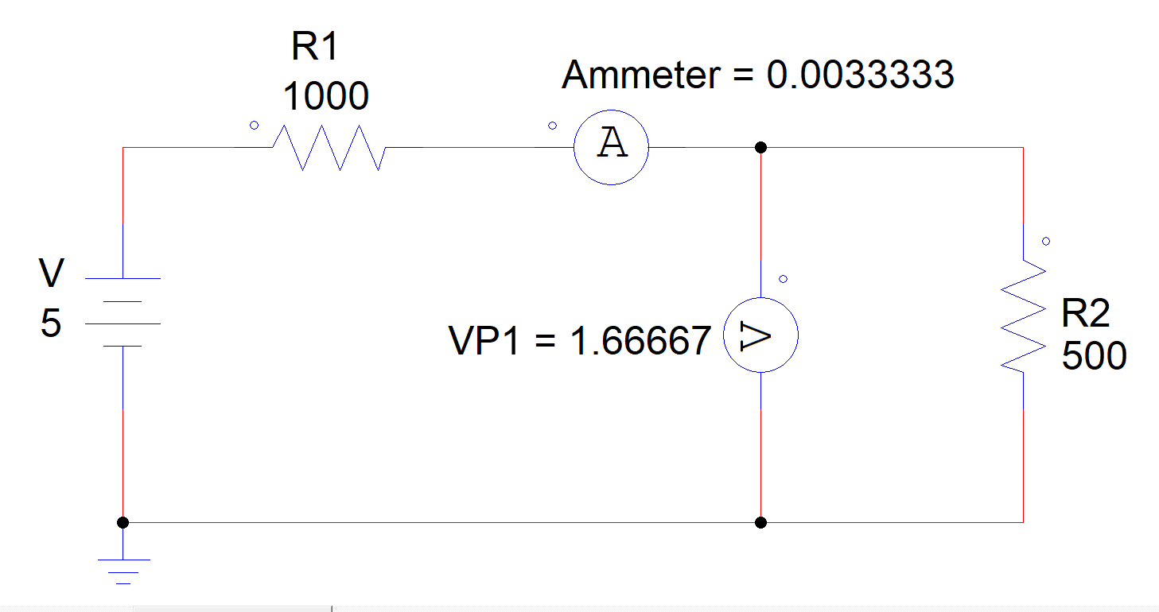

Result:
The measure values of equivalent resistance, voltage and current. The calculate values are given below –

Resistance ( R ) | Volt ( V) | Current ( A)
0.1 | 4.999 | 0.009998
100 | 4.16667 | 0.0083333
200 | 3.57143 | 0.0071429
300 | 3.125 | 0.00625
400 | 2.77778 | 0.0055556
500 | 2.5 | 0.005
600 | 2.27273 | 0.0045455
700 | 2.08333 | 0.0041667
800 | 1.92308 | 0.0038462
900 | 1.78571 | 0.0035714
1000 | 1.66667 | 0.0033333

Graph:
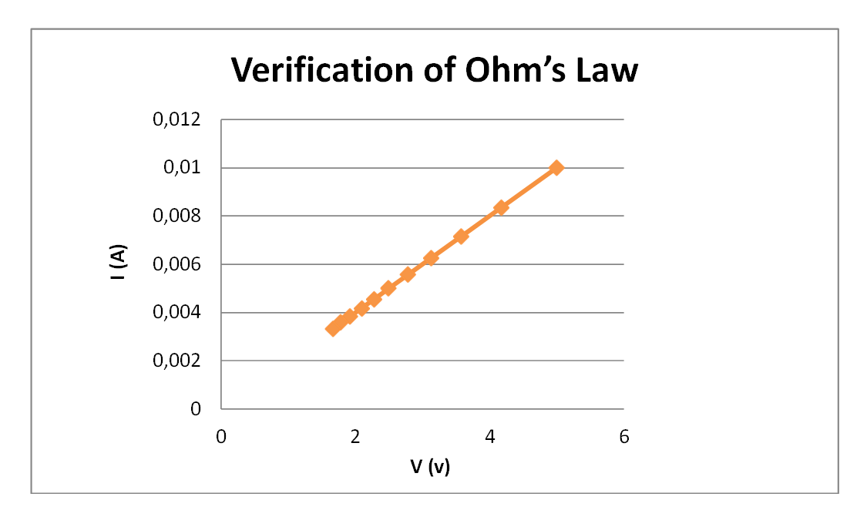
Discussion:
In this experiment, we have measured the voltage and current using a voltmeter and ammeter. According to ohm’s law, current and voltmeter are directly proportional to the constant value of resistance. For this experiment, we used PSIM software tools. In the circuit, we increase the value of resistance from 0.1 to 1000 Ohm. With the increase of the voltage, the current result will increase and resistance stays constant.

